The following information relates to Questions 11, 12 and 13.
month Jan Feb Mar April May June July Aug Sept Oct Nov Dec
seasonal index 1.30 1.21 1.00 0.95 0.95 0.86 0.86 0.89 0.94 0.99 1.07

The table shows the seasonal indices for the monthly unemployment numbers for workers in a regional town.
Question 11
The seasonal index for October is missing from the table.
The value of the missing seasonal index for October is
A. 0.93
B. 0.95
C. 0.96
D. 0.98
E. 1.03 (is it quicker to put it into lists and spreadsheets?) (you can look at the data entered)
Question 12
The actual number of unemployed in the regional town in September is 330.
The deseasonalised number of unemployed in September is closest to
A. 310
B. 344
C. 351
D. 371
E. 640 (read the bold print)
Question 13
A trend line that can be used to forecast the deseasonalised number of unemployed workers in the regional town for the first nine months of the year is given by
deseasonalised number of unemployed = 373.3 – 3.38 × month number
where month 1 is January, month 2 is February, and so on.
The actual number of unemployed for June is predicted to be closest to
A. 304
B. 353
C. 376
D. 393
E. 410

In Question 13, students were given the equation of a trend line for predicting unemployment rates from the month of the year. The trendline had been derived using deseasonalised data. Monthly seasonal indices were also provided. Students were asked to use the trend line to predict the actual unemployment rate in June. The majority of students (59 per cent) were able to predict the deseasonalised unemployment rate from the trend line, but then failed to seasonalise the value they obtained to determine the actual unemployment rate.
Question 3
Grandpa invested in an ordinary perpetuity from which he receives a monthly pension of $584.
The interest rate for the investment is 6.2% per annum.
The amount Grandpa has invested in the perpetuity is closest to
A. $3 600
B. $9 420
C. $94 200
D. $43 400
E. $113 000
Question 3 was unexpectedly challenging, with only 23 per cent of students giving the correct response, option E. A large number of students, 41 per cent, clearly failed to take into account that the pension was paid monthly, not annually, and incorrectly chose option B.

Question 7
Mervyn bought a new lawn mower at a sale.
First, there was a 20% discount from the original price.
Then, an $80 trade-in for his old mower was subtracted from this reduced price.
This left Mervyn with $368 to pay for the new lawn mower.
The original price of the new lawn mower was
A. $468.00
B. $537.50
C. $540.00
D. $560.00
E. $580.00
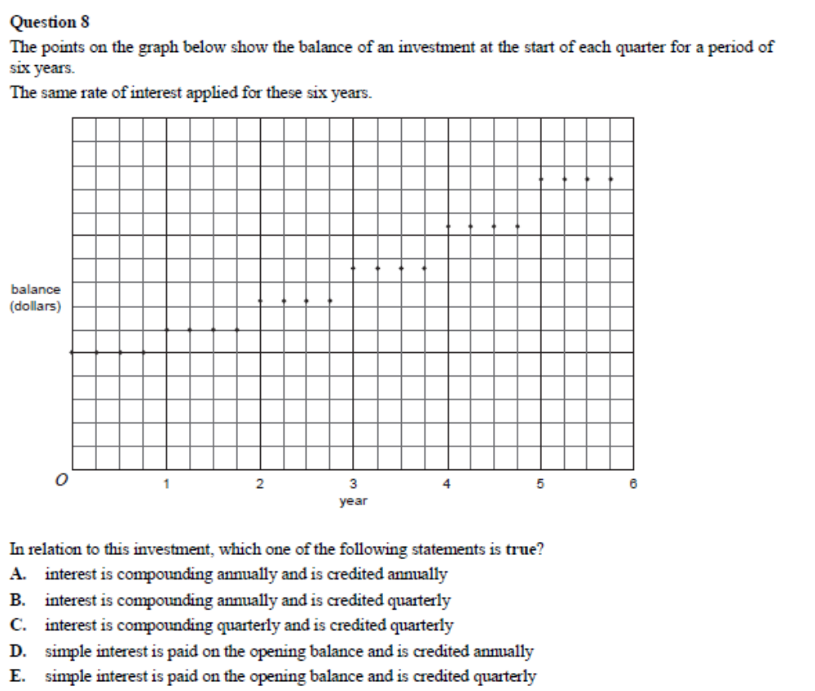
Question 8 concerned the growth of an investment, but was formulated graphically rather than numerically. The aim was to test conceptual understanding of the different forms of investment growth. Only 37 per cent of students were successful in answering this question, choosing option A. Teachers and students are reminded that graphical analysis of business and financial situations is a requirement of the study design.

Question 9
Jenny borrowed $18 000. She will fully repay the loan in fi ve years with equal monthly payments.
Interest is charged at the rate of 9.2% per annum, calculated monthly, on the reducing balance.
The amount Jenny has paid off the principal immediately following the tenth repayment is
A. $1876.77
B. $2457.60
C. $3276.00
D. $3600.44
E. $3754.00

Question 9 was expected to be challenging. Students needed to realise that the future value of a loan represented the remaining principal. A TVM solver (or its equivalent) was needed to assist with the computations. Only 27 per cent of students correctly chose option B. The most common error, made by 23 per cent of students, was to calculate the monthly repayment required to pay off the loan in 10 payments (option A). A further 20 per cent chose option E, erroneously equating the total amount paid off the loan after the tenth repayment to the amount paid off the principal, forgetting that these repayments also included interest.

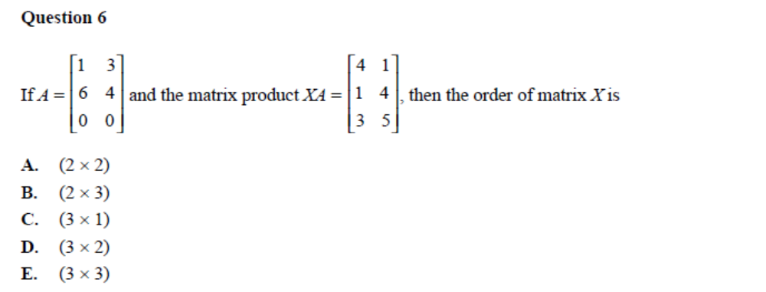
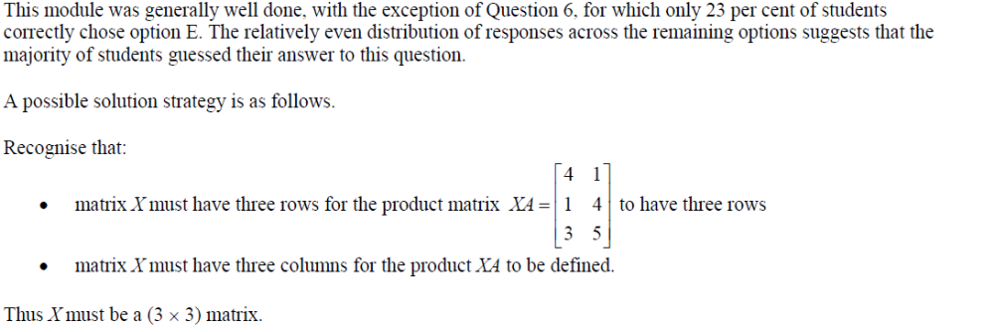

Question 10
The relationship between the variables
size of car (1 = small, 2 = medium, 3 = large)
and
salary level (1 = low, 2 = medium, 3 = high)
is best displayed using
A. a scatterplot.
B. a histogram.
C. parallel boxplots.
D. a back-to-back stemplot.
E. a percentaged segmented bar chart.

Question 10 assessed the second dot point in the topic ‘Displaying and describing relationships in bivariate data’ (see page 121 of the Mathematics VCE Study Design). The fact that only 37 per cent of students correctly answered this relatively straightforward question suggests that this dot point may require further emphasis in the classroom.

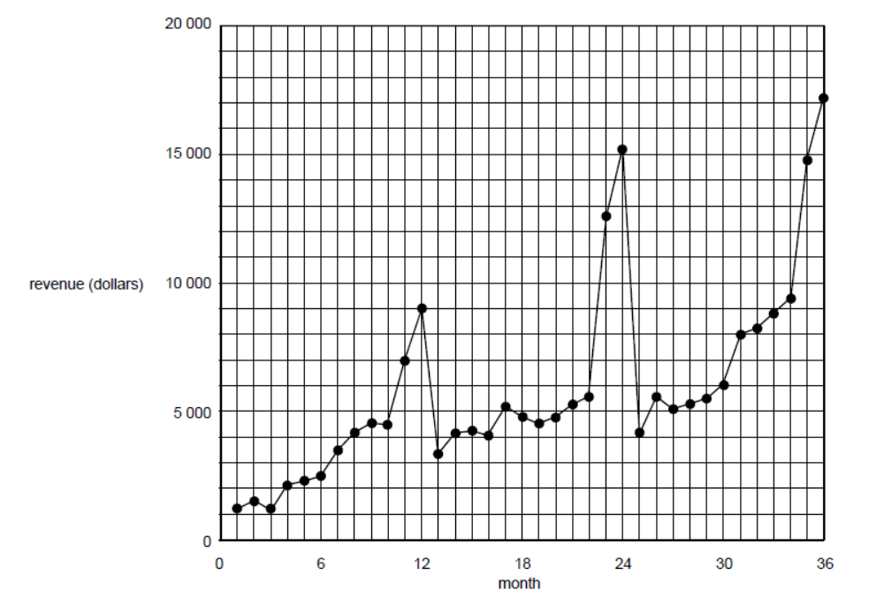
Question 12
A three median trend line is fitted to this data.
Its slope (in dollars per month) is closest to
A. 125
B. 146
C. 167
D. 188
E. 255

Question 12 required students to determine the slope of a three median line fitted to a scatterplot. This is a standard technique, but one which students clearly find difficult. Only 37 per cent of students obtained the correct answer, 167 (option C). The key to successfully answering Question 13 was to correctly locate the coordinates of the median points of the bottom one third of data points and top one third of data points and then use these points to determine the slope.
- From the graph, for the bottom one third of data points, the median point is seen to lie midway between the data points for month 6 and month 7. It has the coordinates (6.5, 3000).
- From the graph, for the top one third of data points, the median point is seen to lie midway between the data points for month 30 and month 31. It has the coordinates (30.5, 7000).

• The slope of the three median line is then given by 70003000166.6730.56.5−=−, correct to two decimal places, which is closest to 167 (option C).
A common mistake was to use month 6 and month 30 to determine the median, giving a slope closest to 146 (option B).

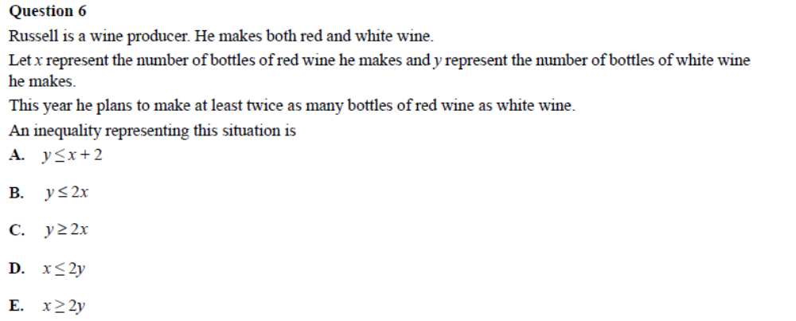
In Question 6, the correct answer of x ≥ 2y (option E) was obtained by only 34 per cent of students. The most popular, but incorrect, choice made by 43 per cent of students was y ≤ 2x (option B). In terms of the problem at hand, this inequality directly translates to, ‘the number of bottles of white wine is less than or equal to twice the number of bottles of red wine’. This is a true statement but is not the constraint specified.
Question 7
At the start of each year Joe’s salary increases to take inflation into account.
Inflation averaged 2% per annum last year and 3% per annum the year before that.
Joe’s salary this year is $42 000.
Joe’s salary two years ago, correct to the nearest dollar, would have been
A. $39 900
B. $39 925
C. $39 926
D. $39 976
E. $39 977

An incorrect solution strategy, which was used by the 42 per cent of students who chose option B, was to first depreciate his current salary of $42 000 by 3% and then by 2% to give the answer $39 925.20 (42 000 × 0.97 × 0.98 = 39 925.20). The error here is that, for example, a 3% depreciation of this year’s salary is not equal to a 3% increase in the previous year’s salary. This is because the percentages are applied to different bases.
= number of monthly repayments × amount of each repayment – 250 000
A TVM solver can then be used to determine the monthly repayments, giving $1938.2473. Therefore, the total interest paid = 240 × 1938.2473 – 250 000 = 215 179.352, or around $215 000.
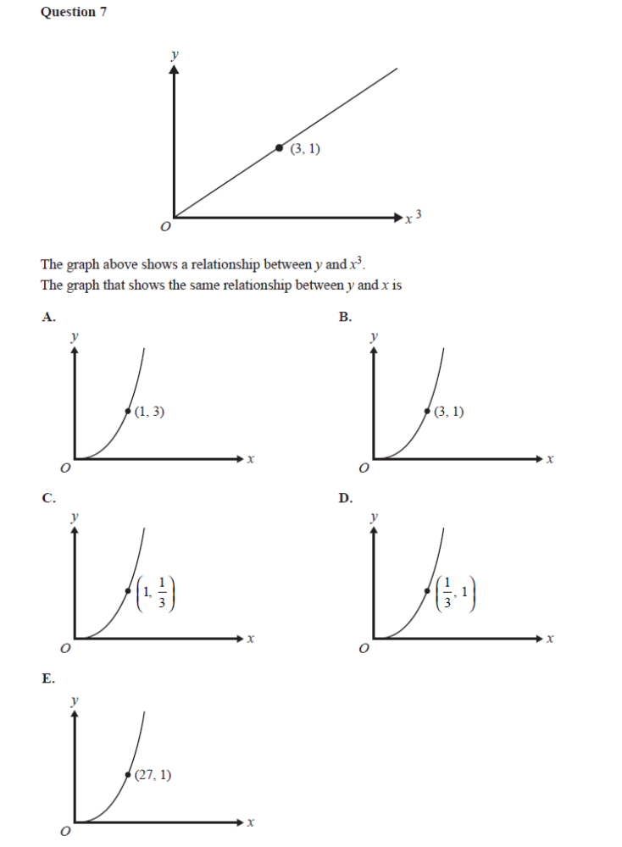
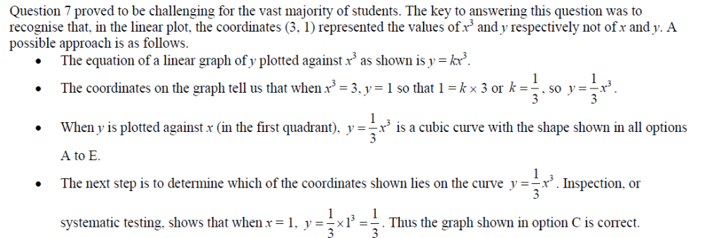
Question 8
Brad investigated the cost of buying a $720 washing machine under a hire purchase agreement. A deposit of $180 is required and the balance will be paid in 24 equal monthly repayments. A flat interest rate of 12% per annum applies to the balance.
Brad correctly calculated the monthly repayment to be
A. $22.50
B. $25.20
C. $26.10
D. $27.90
E. $29.70
Question 9
Petra borrowed $250 000 to buy a home. The interest rate is 7% per annum, calculated monthly on the reducing balance over the life of the loan. She will fully repay the loan over 20 years with equal monthly instalments. The total amount of interest she will pay on the loan is closest to
A. $215 000
B. $266 000
C. $281 000
D. $350 000
E. $465 000
Question 8 was based on a two-year hire purchase agreement. The correct answer was $27.90 (option D). With a success rate of 36 per cent, this question was not well done. However, another 30 per cent of students started correctly, but only took into account one year’s interest, not two, to obtain the answer $25.20 (option B).
As expected, Question 9 was challenging and only 37 per cent of students arrived at the correct solution of $215 000 (option A). This question required students to determine the total amount of interest paid when repaying a loan over 20 years. The key to answering this question was to realise that: total interest paid = total amount repaid over 20 years – the amount borrowed
= number of monthly repayments × amount of each repayment – 250 000
A TVM solver can then be used to determine the monthly repayments, giving $1938.2473. Therefore, the total interest paid = 240 × 1938.2473 – 250 000 = 215 179.352, or around $215 000.
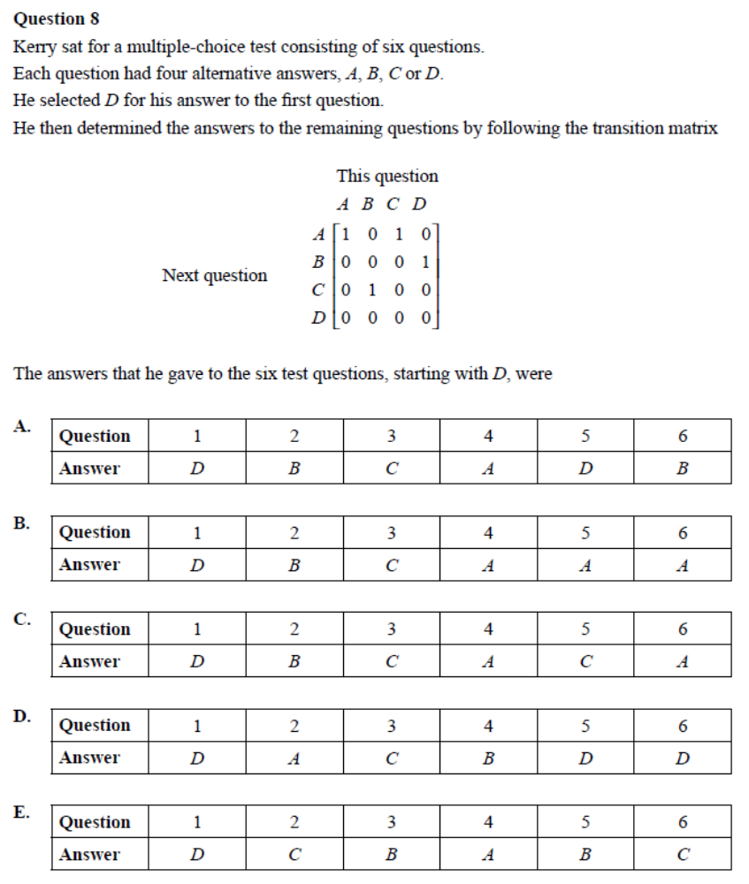
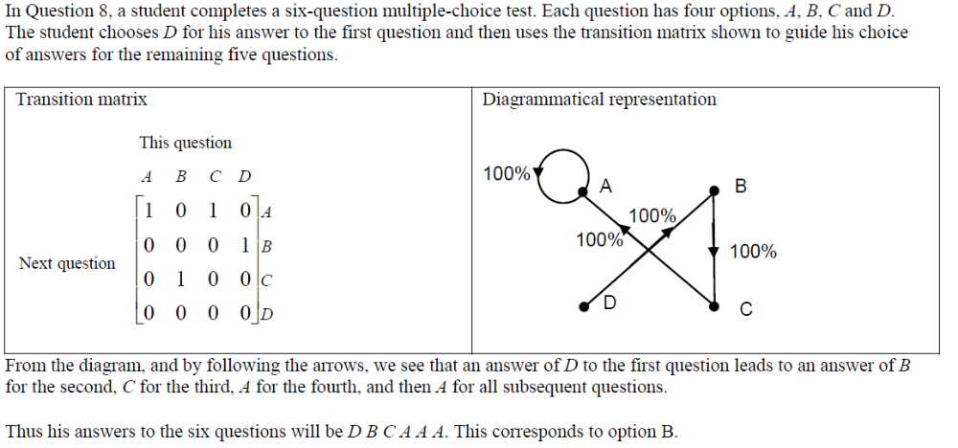
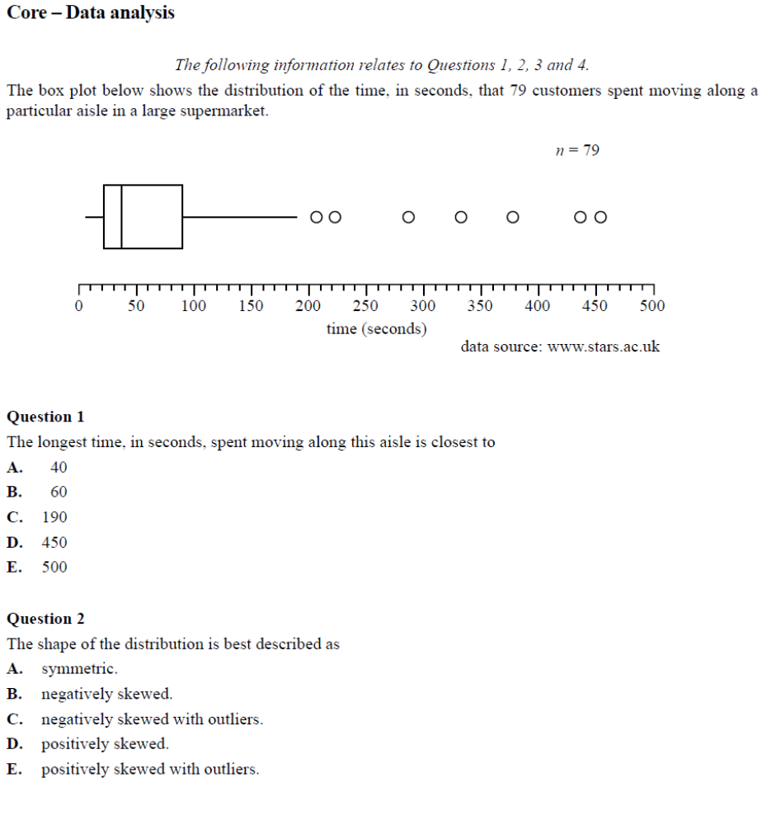
Question 3
The number of customers who spent more than 90 seconds moving along this aisle is closest to
A. 7
B. 20
C. 26
D. 75
E. 79
Question 4
From the box plot, it can be concluded that the median time spent moving along the supermarket aisle is
A. less than the mean time.
B. equal to the mean time.
C. greater than the mean time.
D. half of the interquartile range.
E. one quarter of the range.
The pulse rates of a large group of 18-year-old students are approximately normally distributed with a mean of
75 beats/minute and a standard deviation of 11 beats/minute.
Question 6
The percentage of 18-year-old students with pulse rates less than 75 beats/minute is closest to
A. 32%
B. 50%
C. 68%
D. 84%
E. 97.5%
Question 7
The percentage of 18-year-old students with pulse rates less than 53 beats/minute or greater than 86 beats/minute
is closest to
A. 2.5%
B. 5%
C. 16%
D. 18.5%
E. 21%
Question 7 required two applications of the 68-95-99.7% rule to obtain the correct answer. One application to determine the percentage of students with pulse rates less than 53 beats/minutes (2.5%) and the second to determine the percentage of students with pulse rates greater than 86 beats/minutes (16%). The percentage of students with pulse rates less than 53 beats/minutes or greater than 86 beats/minutes is then the sum of these two values (18.5% – option D) and 44 percent of students gave this correct response. In answering any question requiring the use of the 68-95-99.7% rule, a useful strategy is to first draw a normal curve and shade in the required area(s) as defined by the problem statement. This was an essential first step in answering Question 7.
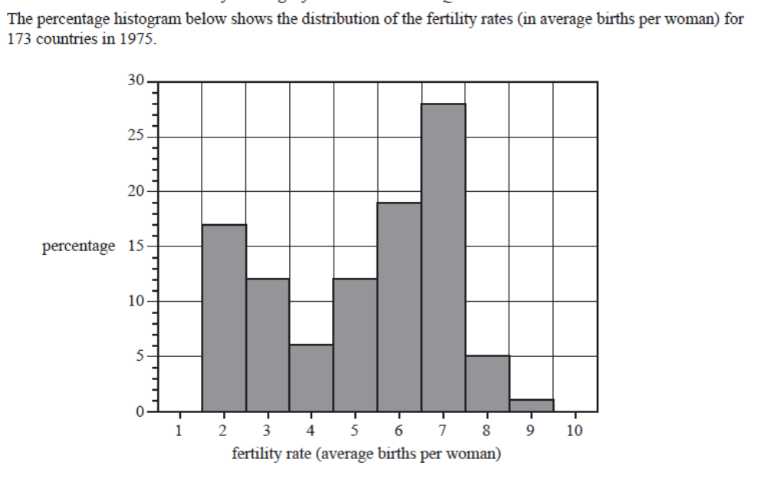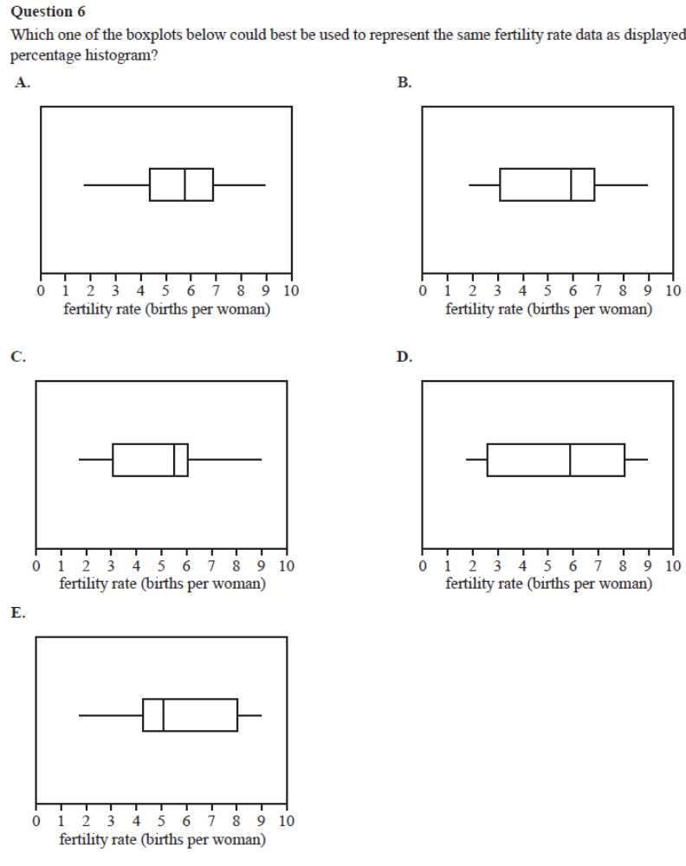Question 6 involved matching a boxplot with a given histogram and 43 per cent of students were able to answer
correctly. To successfully complete this task, students needed to recognise that a boxplot is a graphical display of the five-number summary of a data set, namely, the minimum value, the first quartile (Q1), the median (M), the third quartile (Q3) and the maximum value. As all boxplots had whiskers extending to the same minimum and maximum values, a systematic approach to this question would have been to estimate the values of the median and the first and third quartiles, then look for a match (option B). Students who attempted to answer the question purely by inspection would have found it difficult to obtain the correct answer.
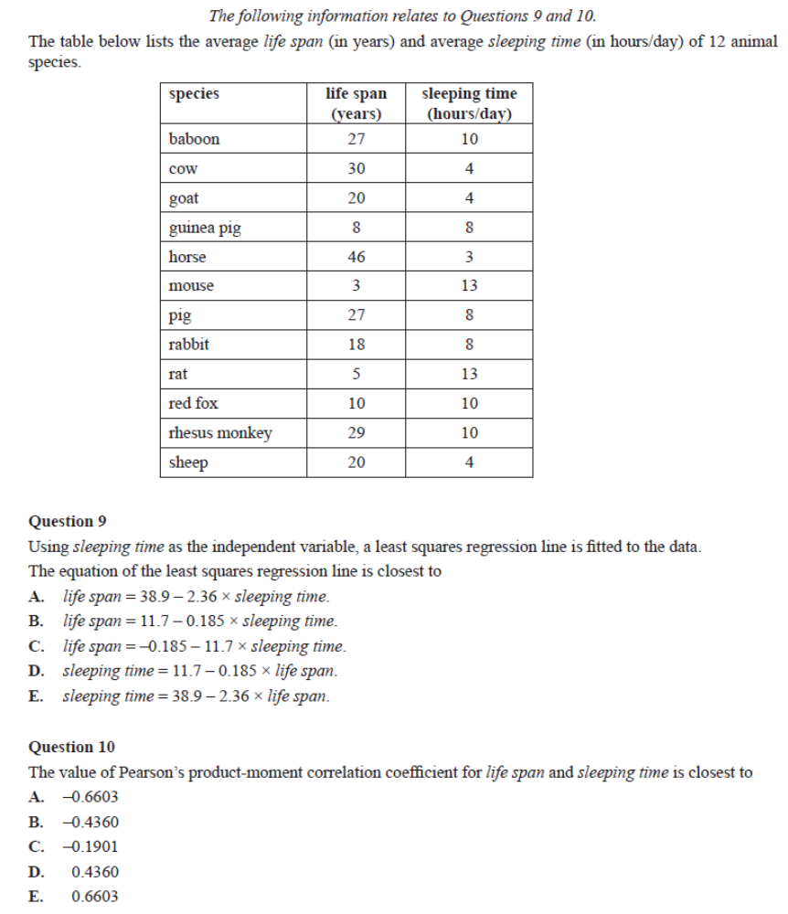Question 9 had a success rate of 49 per cent. A further 22 per cent of students chose option B, making the common error of automatically assuming (incorrectly in this case) that the first variable appearing in the table was the independent variable.
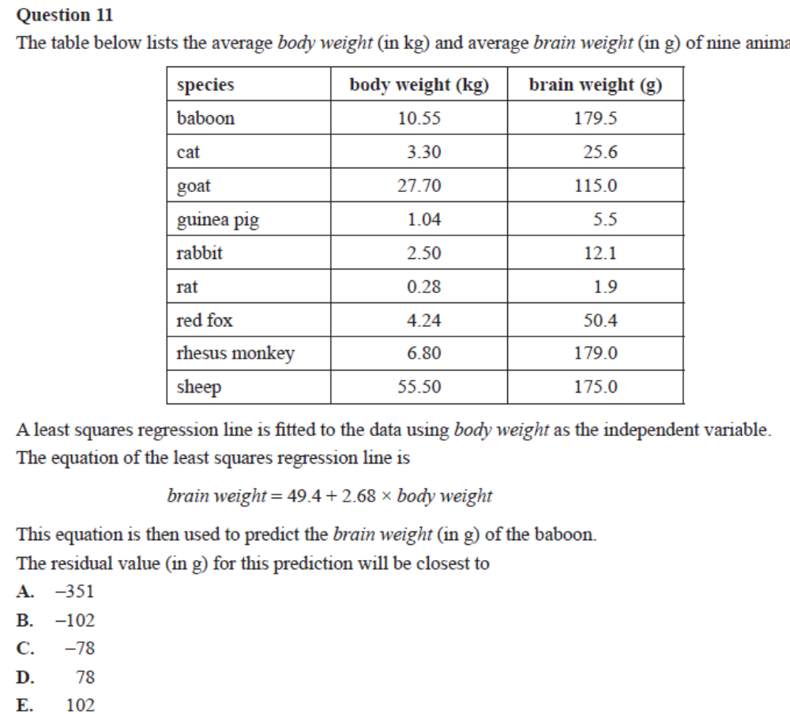
In Question 11, students were given the body weights and brain weights of nine animals, and the equation to a least
squares regression line determined from this data. The correct response was chosen by 47 per cent of students. Students
were expected to first use the equation of the regression line to determine the predicted brain weight for the designated
animal (the baboon) and then use this value, along with the animal’s actual brain weight, to determine the residual value
(the error of prediction). A significant number of students, 28 per cent, correctly completed the first part of the task –
correctly calculating the predicted brain weight – but did not go any further and this led them to choose option D.
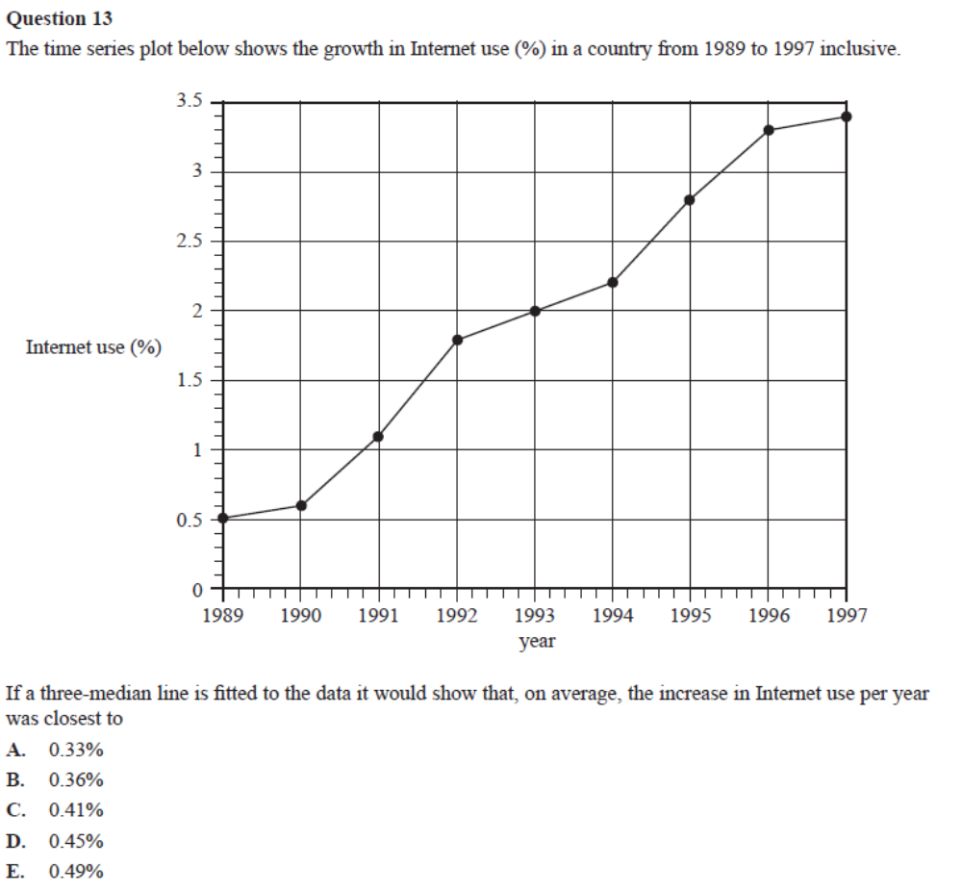

To answer Question 13, students were required to determine the slope of a three median line when fitted to a scatterplot. This is a standard technique, but one which students clearly find difficult. Only 40 per cent of students chose the correct answer, 0.45% (option D). The key to successfully answering Question 13 was to correctly locate the coordinates of the median points of the bottom one third of data points and top one third of data points. These two points are then used to determine the slope of the three median line. 